TASK:3

**CREATING A MINIKUBE SERVICE TO HANDLE CONTAINERS**

I.creating a deployment



II.exposing the deployment



III.checking for pod

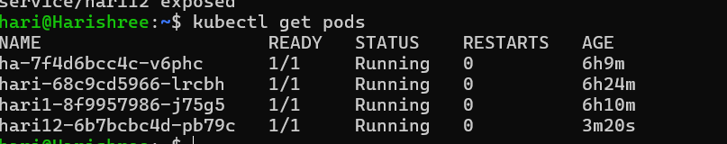

IV.opening the minikube service

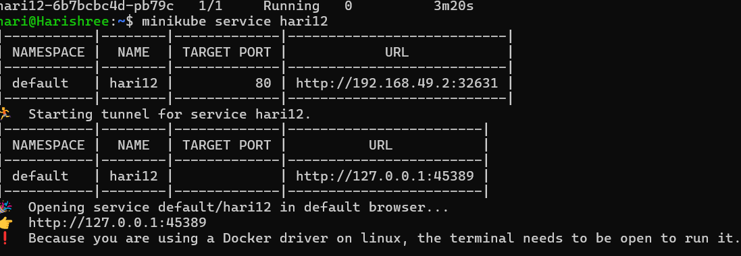

VI.output

